**Issue No: 1**

<http://www.acumencs.com/pitchli-st/register>

What the hell happened to this form?

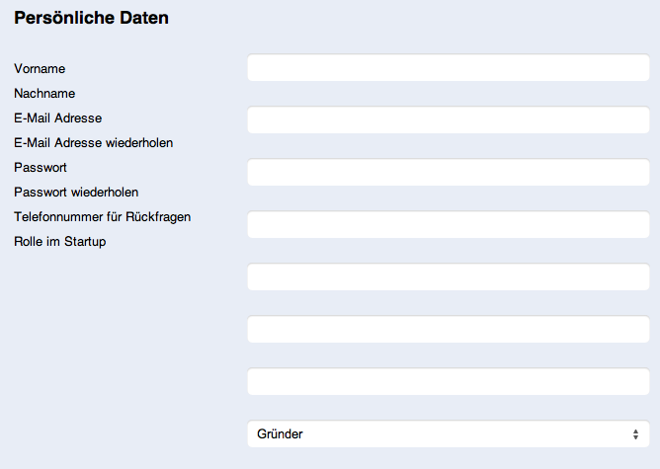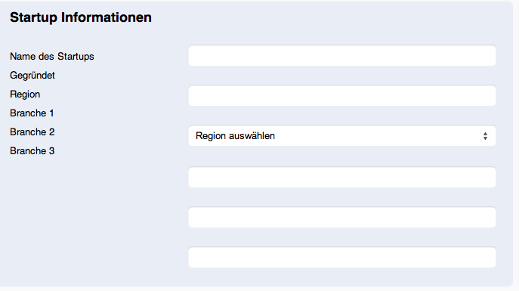

**Tester’s Comment: Done**

See the screenshot:

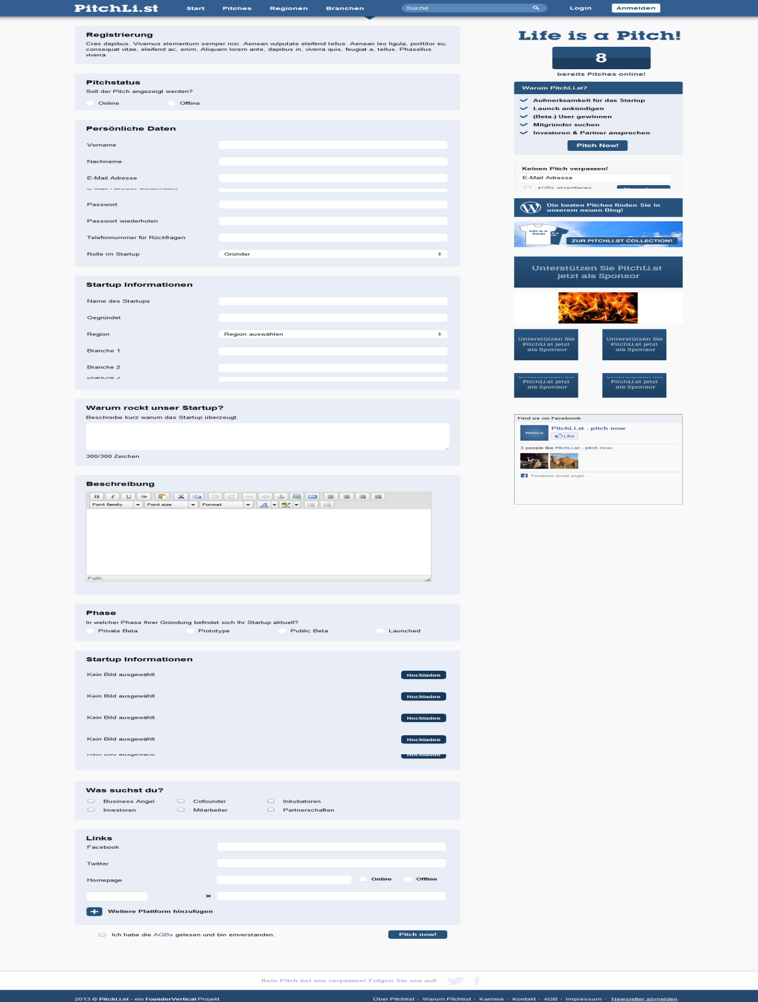

**Issue No: 2**

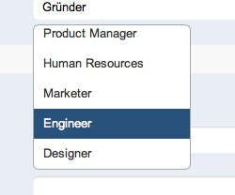

show all roles without scrolling

**Tester’s Comment: Done**

See the screenshot:

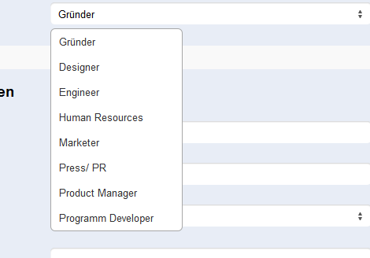

**Issue No: 3**

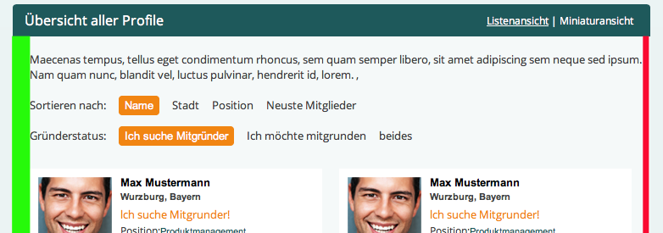

**Tester’s Comment: Done**

See the screenshot:

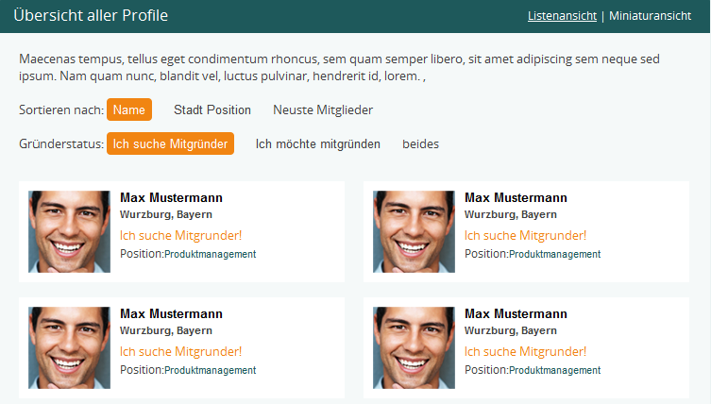

**Issue No: 4**

cid:CA8BF991-0273-49CA-884A-C129C00806F7@Speedport_W_700V

 Es wurden 4 FounderMatches in Bayern gefunden.

**Tester’s Comment: Not Done**

See the screenshot:

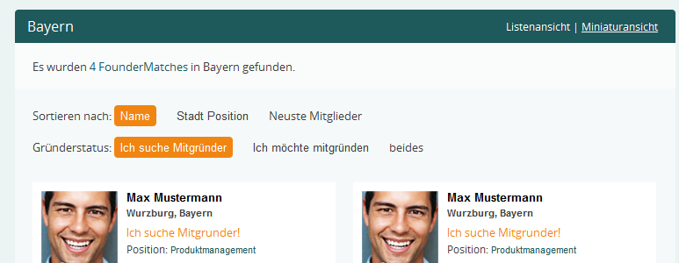

**Issue No: 5**

cid:056C179A-D9F6-4F4B-BDC3-76BE707B174C@Speedport_W_700V

only the green space is right!

<http://acumencs.com/founder/region.html>

<http://acumencs.com/founder/profile.html>

**Tester’s Comment: Not Done**

**Issue No: 6**

always: Ich möchte mitgründen

not: Ich möchte mitgrunden

**Tester’s Comment: Done**

See the screenshot:

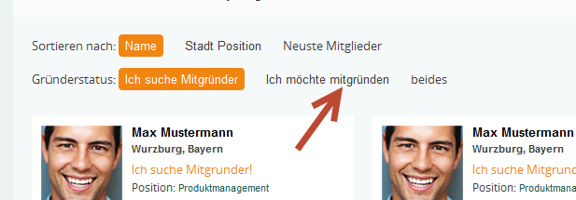

**Issue No: 7**

Paging like PitchList

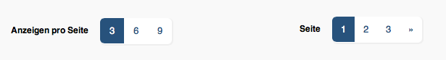

Anzeigen pro Seite   8  16  24

**Tester’s Comment: Done**

